Hypoxia: A Silent Threat to Marine Life.
Hypoxia means low oxygen and is a problem for estuaries and coastal waters especially. Large areas of our coastal waters throughout the world they're becoming so polluted that they lack enough oxygen, One of life's basic building blocks. This circumstance is named "hypoxia”. The consequences of hypoxia include the killing of fish and losses in shellfish beds. Because hypoxia often takes place in estuaries or near shore areas where the water is poorly mixed, nurseries of fish and shellfish ecosystems are also affected by it (Are et al., 1999). Depletion in dissolved oxygen concentration in the water column can push marine environment towards hypoxic (O2≤ 2mg/l or O2≤ 60µmol/kg) and/or anoxic (O2≤ 0mg/l) conditions, and further formation of oxygen minimum zones (OMZs, O2˂ 0.7mg/l or O2˂ 21µmol/kg) in the coastal areas (Satpathy et al., 2013). Typically, depth of hypoxia ranges between near surface to 1500m (Kamykowski & Zentara, 1990). In the Bay of Bengal hypoxia ranges between near surface to 1100m.Organic carbon loading ,the process of eutrophication(Nixon, 1995), coupled to restricted circulation is the primary mechanism and condition that leads to hypoxia(Eldridge & Roelke, 2012).Organic carbon increase due to inorganic carbon loading if ocean have limited nutrients and in this condition inorganic nutrients enhance primary productivity, that’s why produced organic carbon helps to bacterial production, zooplankton grazing, fisheries production and also increases flow of organic materials to bottom water sediments. To metabolize these organic materials DO is used and DO level decreases in the water column but under limited circulation DO does not restocked and results hypoxia (Eldridge & Roelke, 2012). Climate change is decreasing the concentration of oxygen in the Ocean Open. The combined consequences of climate change and Excess nutrients (from sources such as Farm runoff and human waste) lead to oxygen loss in Marine and Coastal Systems. (Breitburg & Grégoire, 2018)
Hypoxia events are natural phenomena. For, instance, hypoxia has been found in the open waters of the Black Sea. Because of bad water exchanges, there have been thousands of
years of current with the Sea of the Mediterranean (Eldridge & Roelke, 2012). OMG is the zone in which oxygen saturation in seawater in the ocean is at lowest. low dissolved oxygen potentially stresses or kill marine life. Hypoxia or dead zone is a key stressor of marine environment and occurring in over 400 physically diverse marine ecosystem worldwide (Diaz and Rosenberg, 1995b, 2008; Conley et al., 2009). the lack of oxygen alters the structure and functioning of benthic communities (Nilsson and Rosenberg, 2000). It also can change predator-prey relationship (Eriksson et al., 2005). Hypoxia has become an increasing problem in marine ecosystem around the world (Virtanen et al., 2019).

Status of world ocean hypoxia and OMZs:
In the open ocean and coastal waters, oxygen levels have been declining since at least the middle of the 20th century(Breitburg et al., 2018). During the past 50years, the area of low oxygen water has increased by 4.5 million km² in the open ocean. Approximately 1gigaton of oxygen is losing by the world ocean each year. The largest coastal water hypoxic zone is in the Baltic sea and nearly 80000 km² has dissolved oxygen less than 2mg/l. now reported that over 500 coastal water bodies has dissolved oxygen concentration less than 2.2mg/l.(Breitburg & Grégoire, 2018). The total OMZs(Oxygen Minimum Zones) area in the global ocean is 30.4±4 million of km² and volume is 102±15 million of km³ and its respectively 8% and 7% of the global ocean(Paulmier & Ruiz-pino, 2009)
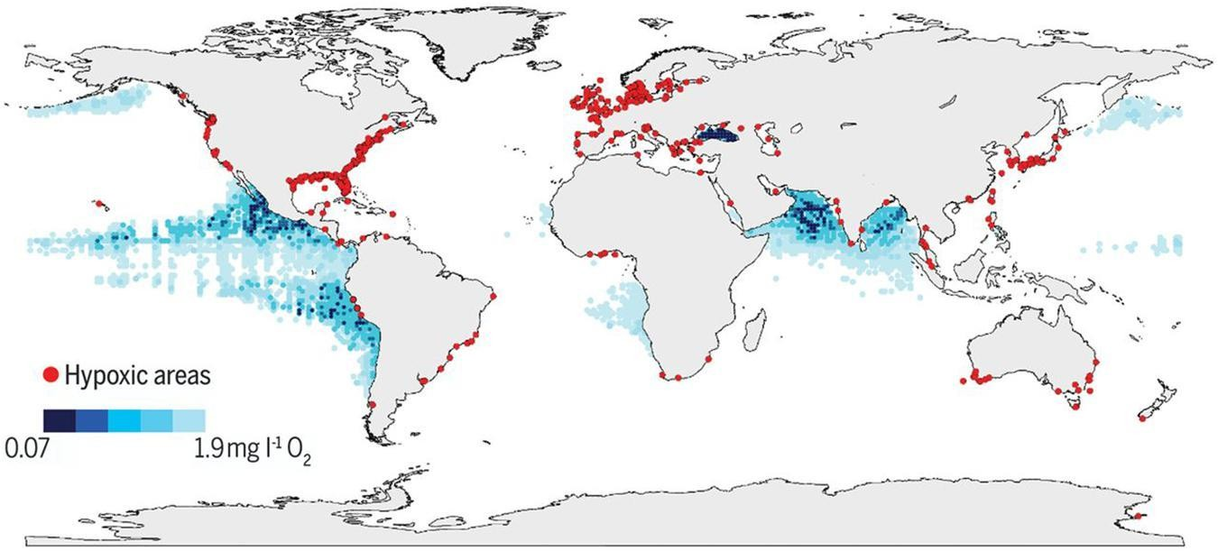
Figure 1: global map of open and coastal ocean hypoxia (Benway et al., 2019).
Over the past 50 years the open ocean lost 2% or 4.8±2.1 petamoles (77 billion metric tons) of its oxygen. And over the past 50 years the OMZs have expanded by an area almost the same size of European Union (4.5 million km²) in the open ocean, and anoxic zone has quadrupled over the same time (Breitburg et al., 2018)

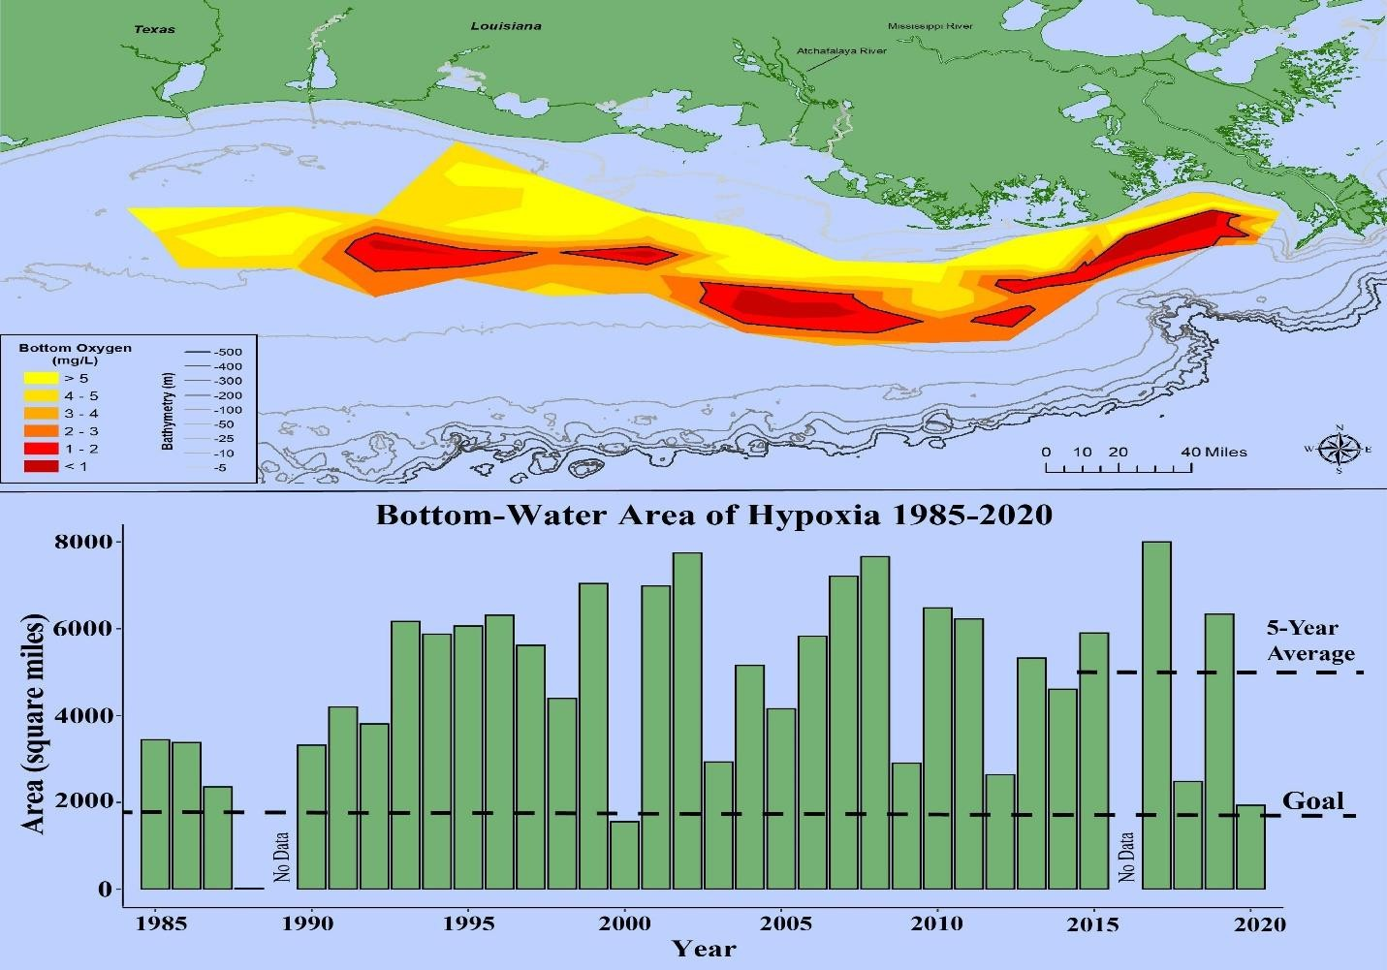
Figure 2: bottom water hypoxia of Gulf of Mexico (source: NOAA)

Hypoxia Status in the Bay of Bengal:
At depth of 70m and below there is almost 60000km² hypoxia which is almost half size of Bangladesh. This is the third largest Oxygen Minimum Zone. On the outer shelf, hypoxic conditions are persistent off Bay of Bengal above 100m and there is OMZ (O2 < 0.7 mg/l) From 150 m to approximately 600 m and over past few decades the Bay of Bengal show constancy in OMZ, shelf water column hypoxia and anoxia was not prevalent in the BOB (Satpathy et al., 2013). Evidence shows that, as reflected by its intensification, the Bay of Bengal OMZ and hypoxia is alarmingly rising. The hypoxia phenomenon was not constant and distributed vertically within the BOB's OMZ due to the upwelling and physical force driven by the local wind (Satpathy et al., 2013).

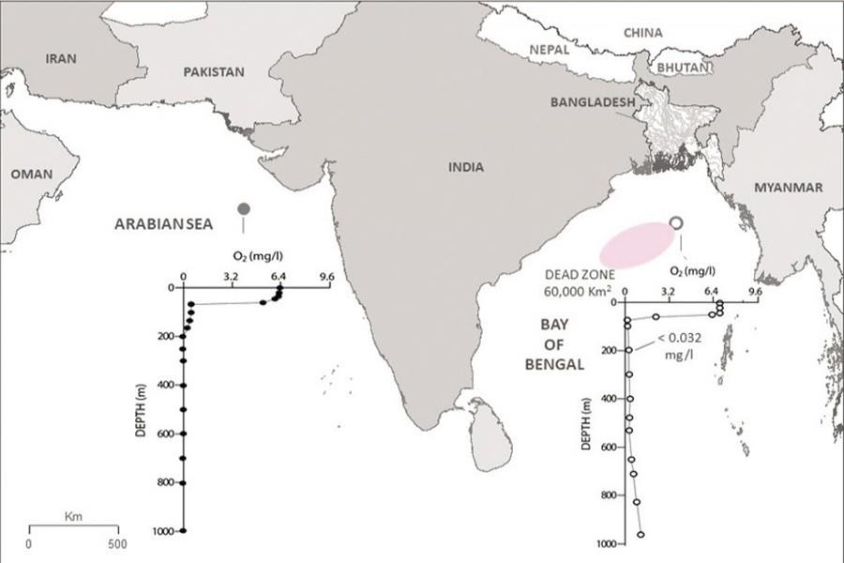
Figure 3:dead zone in the Bay of Bengal(source: Dr Quamrul Ahsan is former Assistant Professor and Dr Anisul Haque is Professor, Institute of Water and Flood Management (IWFM), Bangladesh University of Engineering and Technology (BUET), Dhaka)

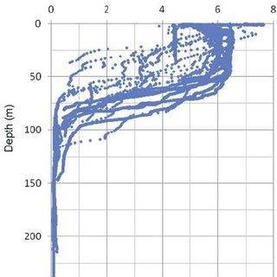
Figure:4Vertical distribution of oxygen profile in southwestern Bay of Bengal, (11–13°N; 79– 80°E) up to 250 m depth during 2010. ((Satpathy et al., 2013)

References
Are, W., Effects, T. H. E., & Hypoxia, O. F. (1999). What are the effects of hypoxia?
Benway, H. M., Lorenzoni, L., White, A. E., Fiedler, B., Levine, N. M., Nicholson, D. P.,
DeGrandpre, M. D., Sosik, H. M., Church, M. J., O’Brien, T. D., Leinen, M., Weller, R. A., Karl, D. M., Henson, S. A., & Letelier, R. M. (2019). Ocean time series observations of changing marine ecosystems: An era of integration, synthesis, and societal applications
Frontiers in Marine Science, 6(JUL), 1–22. https://doi.org/10.3389/fmars.2019.00393
Breitburg, D., & Grégoire, M. (2018). The ocean is losing its breath. Unesco, 11, 1–43. https://theconversation.com/the-ocean-is-losing-its-breath-and-climate-change-is-making-it- worse-66192
Breitburg, D., Levin, L. A., Oschlies, A., Grégoire, M., Chavez, F. P., Conley, D. J., Garçon, V., Gilbert, D., Gutiérrez, D., Isensee, K., Jacinto, G. S., Limburg, K. E., Montes, I., Naqvi, S.
W. A., Pitcher, G. C., Rabalais, N. N., Roman, M. R., Rose, K. A., Seibel, B. A., … Zhang,
J. (2018). Declining oxygen in the global ocean and coastal waters. Science, 359(6371). https://doi.org/10.1126/science.aam7240
Deutsch, C. (2011). Climate-Forced Variability of Ocean Hypoxia Climate-Forced Variability of Ocean Hypoxia. June 2014. https://doi.org/10.1126/science.1202422
Diaz, R. J., Rosenberg, R., & Sturdivant, K. (2019). 2.5 Hypoxia in estuaries and semi-enclosed seas. Ocean Deoxygenation: Everyone’s Problem, 20. https://portals.iucn.org/library/node/48892
Eldridge, P. M., & Roelke, D. L. (2012). Hypoxia in Waters of the Coastal Zone: Causes, Effects, and Modeling Approaches. In Treatise on Estuarine and Coastal Science (Vol. 9, Issue January 2012). Elsevier Inc. https://doi.org/10.1016/B978-0-12-374711-2.00911-6
Gray, J. S., Wu, R. S., & Or, Y. Y. (2014). Effects of hypoxia and organic enrichment on the coastal marine environment. September. https://doi.org/10.3354/meps238249
Kamykowski, D., & Zentara, S. J. (1990). Hypoxia in the world ocean as recorded in the historical data set. Deep Sea Research Part A, Oceanographic Research Papers, 37(12), 1861–1874. https://doi.org/10.1016/0198-0149(90)90082-7
Krueger, S. (2018). What is Dissolved Oxygen? DISSOLVED OXYGEN (DO) What Factors Affect Dissolved Oxygen (DO)? How does oxygen enter the water? 100. https://www.monroecounty-fl.gov/DocumentCenter/View/15692/Dissolved-Oxygen-Fact- Sheet
Paulmier, A., & Ruiz-pino, D. (2009). Progress in Oceanography Oxygen minimum zones ( OMZs ) in the modern ocean. Progress in Oceanography, 80(3–4), 113–128. https://doi.org/10.1016/j.pocean.2008.08.001
Satpathy, K. K., Panigrahi, S., Mohanty, A. K., & Sahu, G. (2013). Severe oxygen depletion in the shallow regions of Bay of Bengal off Tamil Nadu coast Severe oxygen depletion in the shallow regions of the Bay of Bengal off Tamil Nadu coast. May, 9–12.

